18.28: a) The volume per molecule is

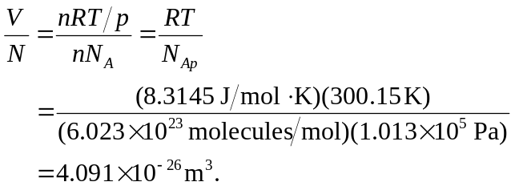

If this volume were a cube of side L,

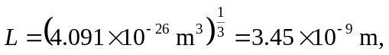

which is (b) a bit more than ten times the size of a molecule.

